**date command:**

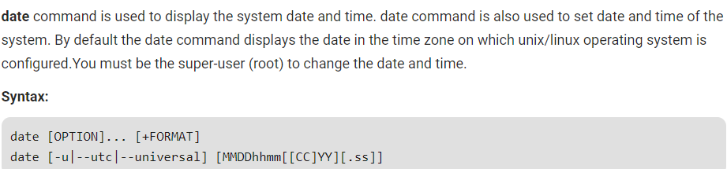

**date (no option):** With no options, the date command displays the current date and time, including the abbreviated day name, abbreviated month name, day of the month, the time separated by colons, the time zone name, and the year.

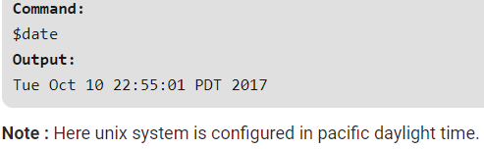

**-u Option:** Displays the time in GMT (Greenwich Mean Time)/UTC(Coordinated Universal Time )time zone.

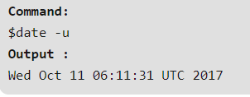

**–date or -d Option:** Displays the given date string in the format of date. But this will not affect the system’s actual date and time value. Rather it uses the date and time given in the form of string.

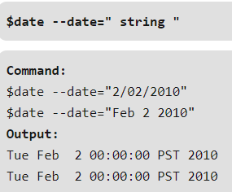

Using **–date** option for displaying past dates:

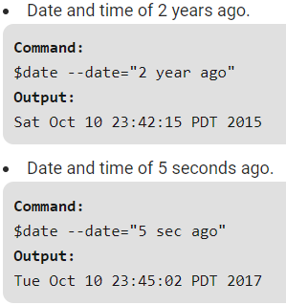

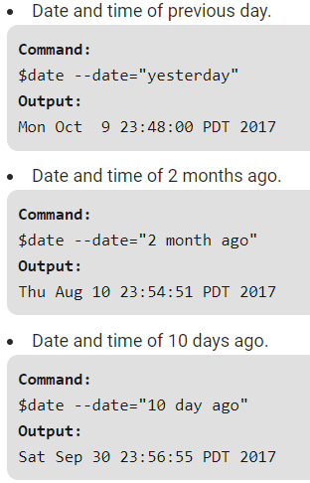

Using **–date** option for displaying future date:

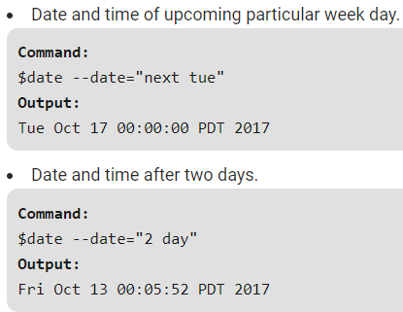

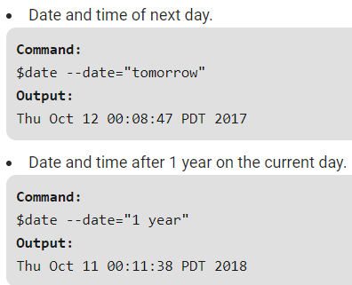

**-s or –set Option:** To set the system date and time -s or –set option is used.

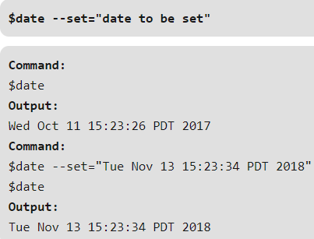

**–file or -f Option:** This is used to display the date string present at each line of file in the date and time format.This option is similar to –date option but the only difference is that in –date we can only give one date string but in a file we can give multiple date strings at each line.

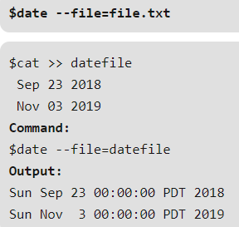

**-r Option:** This is used to display the last modified timestamp of a datefile .

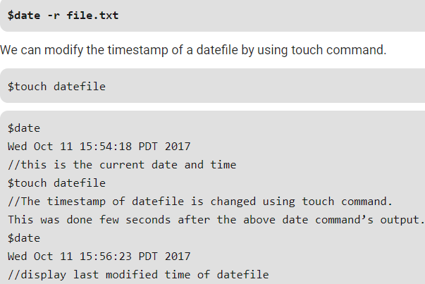

**List of Format specifiers used with date command:**

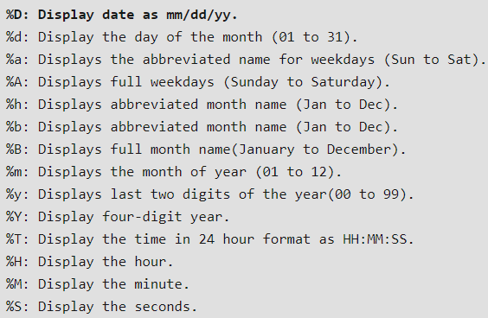

**Example:**

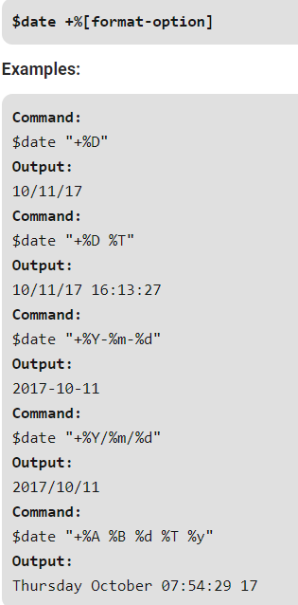

**Changing the time zone:**

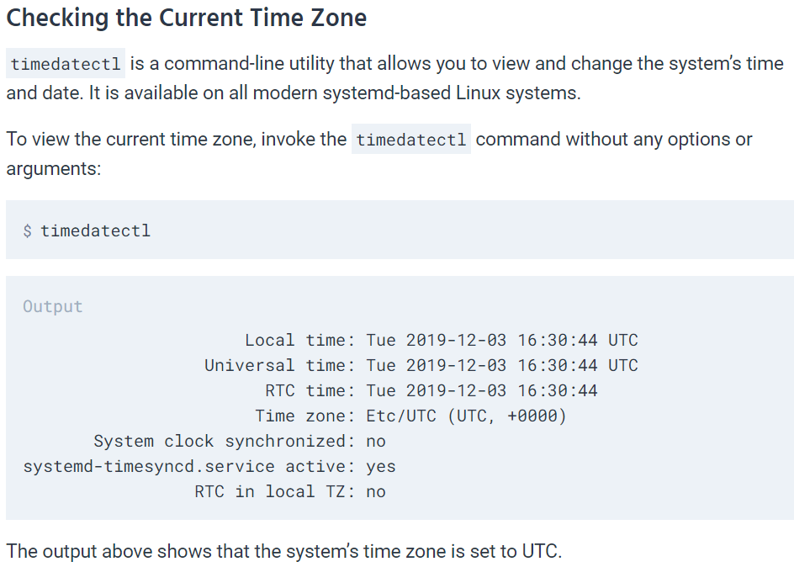

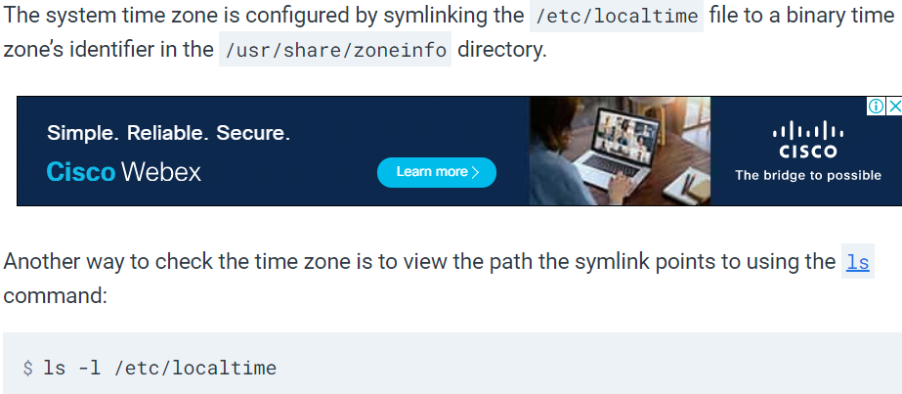

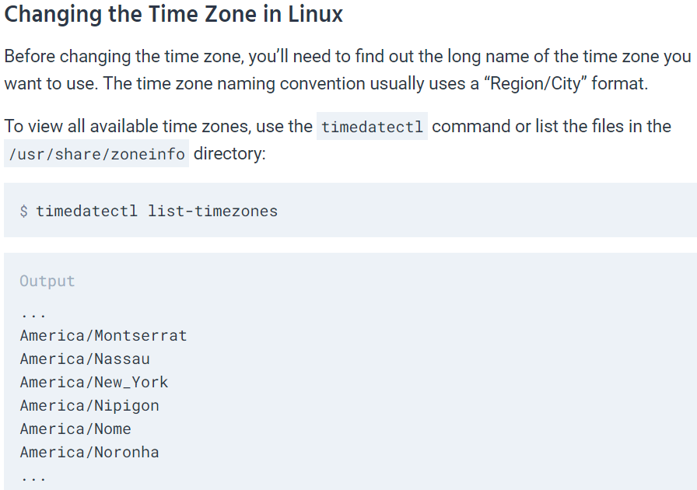

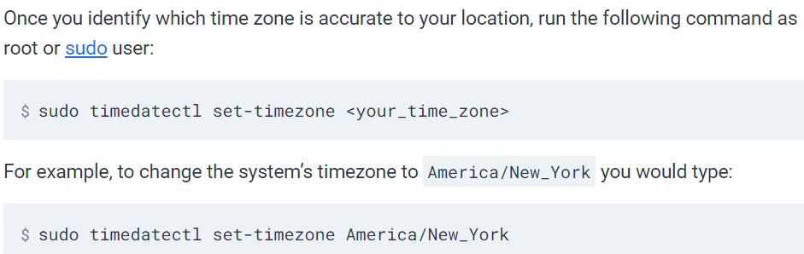

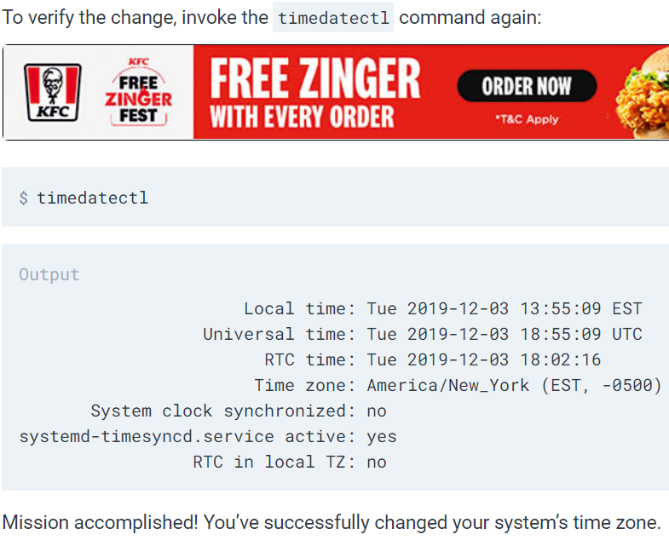

**time command:**

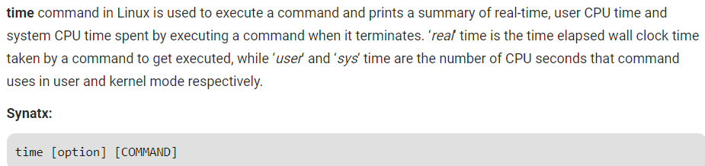

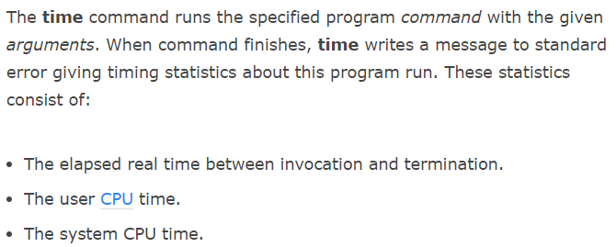

**Examples:**

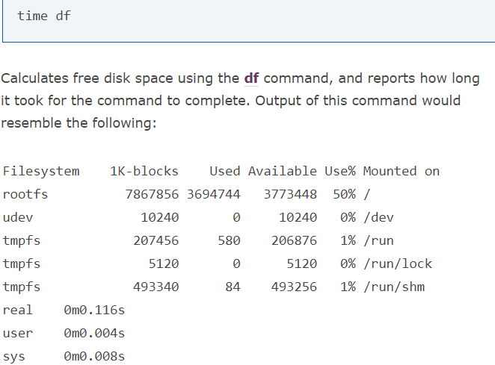

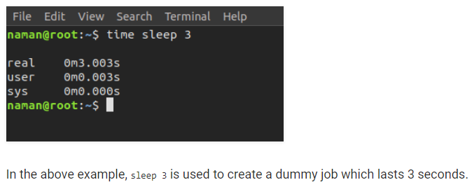

**Options:**

